BOOK OFFER ONE, 2026 - INSTRUCTIONS
The Alan Duff Charitable Foundation
Kia ora Principal and Duffy Coordinator,

We are excited to bring you Book Offer One, 2026.

This offer includes five specially selected titles - one from each level – plus a Te Reo Māori title:

Age 5-6: Toot the Tow Truck
Age 7-9: The Terrible Trio: The (not so) Superheroes
Age 10-12: Tom Gates: Pesky Pets and Parties
Advanced: Disney A twisted Tale: Be Prepared
Te Reo Maori: Te Pī Māhaki

ONLINE ORDERING ONLY
Your pack includes:

- Complimentary highlights preview pack
- Brochures for distribution
- Class Order Form
THANK YOU


For sponsoring the Complimentary Highlights Package!

Important Dates

- Early order Deadline: Monday 9 February 2026
Schools submitting by this date will receive two BONUS books for the library.

- Final Order Deadline: Friday 13 February 2026.

Submit all orders online via:
http://bih.scholastic.co.nz/

Duffy Role Model Assemblies
2nd March – 1st April 2026

Our Role Model team will contact you to arrange a visit and celebrate Book Offer One.
Please hold your books until your Assembly! Regional contacts for queries:

Northland to Auckland: Crystal - Crystal.Finau@booksinhomes.org.nz
Waikato to Wellington: Jacqui - Jacqui.Whyte@booksinhomes.org.nz
South Island: Trina - Trina.Isaako@booksinhomes.org.nz

BOOK OFFER ONE, 2026 - INSTRUCTIONS
The Alan Duff Charitable Foundation

How to Order

- Photocopy the Class Order Form for each teacher.
- Hand out a Brochure to every student.
- Students select FOUR books (any titles) in order of preference and complete the Student Order Form on the back of the brochure. (They will receive two of their four choices.)
- Yellow section: 5-6 year olds
- Blue section: 7-8 year olds
- Purple section: 9-10 year olds
- Green section: 11 years +

- Teachers collate student selections onto the Class Order Form, entering the four book codes for each student.
- Check before submitting:
- School/Teacher name and Room Number are on all forms
- Each student has made four selections
- Enter your Class Order Forms online at: http://bih.scholastic.co.nz/
(Tip: Larger schools may involve a senior student or parent volunteer for online entry)

Remember: Only current students can order. Students starting later can receive Caught Being Good books at your assembly.

Scholastic New Zealand proudly sponsors the complimentary highlights books for your school library.

Please submit by the due date to ensure prompt delivery and enjoy celebrating the love of reading with your students!

CLASS ORDER FORM
The Alan Duff Charitable Foundation

BOOK OFFER 1, 2026

 | 1ST | 2ND | 3RD | 4TH | NAME
1
2
3
4
5
6
7
8
9
10
11
12
13
14
15
16
17
18
19
20
21
22
23
24
25
26
27
28
29
30
31
32
33
34
35

Class: ________________________ Teacher: ____________________________

INSTRUCTIONS FOR ORDERING ONLINE

- Log into bih.scholastic.co.nz
- If you are a new user, please register. You will receive an email verification link
- Select the Offer, e.g. Book Offer 1
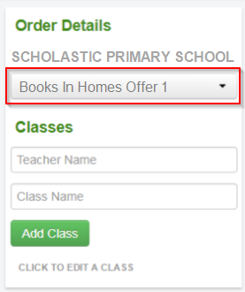

- Add Teacher’s name and Class name, then click ‘Add Class’
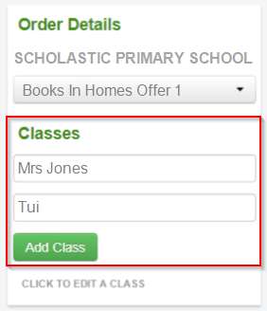

- Fill in the Student names and their choices for each student. (Note: All data is automatically saved)
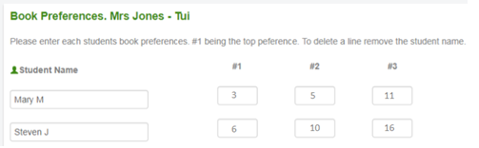

To add another classroom go back to stage 3.
- Once all classes are complete, click ‘CONFIRM ORDER’
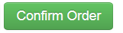
You will see a summary of your order.

- If you are happy with it, click on ‘SUBMIT ORDER’. If not, click on ‘EDIT’ to change it.
Your order will show as pending, meaning it’s been sent to Scholastic for processing.
** You can now view this order and any others in ‘MY ORDERS’ or ‘SUBMITTED ORDERS’ **

