**BOOK OFFER THREE, 2025 - INSTRUCTIONS**

***The Alan Duff Charitable Foundation***

Dear Principal and Duffy Coordinator

We are pleased to present Book Offer Three, 2025.

This includes five specially chosen books one from each level and a Te Reo title:

**Age 5-6:** *The Little Yellow Digger and the Helicopter*

**Age 7-9:** *Super Epic Dragon Quest: The Deadly Fang*

**Age 10-12:** *Ella at Eden Super Special: Paris Adventure*

**Advanced:** *Danger Road*

**Te Reo Maori:** *Kia Heke te Pō*

**ONLINE ORDERING ONLY**

**Please follow these instructions carefully to ensure prompt and efficient delivery of your books.**

This package contains the following items:

* **Complimentary highlights preview pack**
* **Brochures**
* **Class Order Form**
* **Scholastic sponsored – Duffy Champion Award**
* **THANK YOU SCHOLASTIC – PROUDLY SPONSORING THE COMPLIMENTARY HIGHLIGHTS PACKAGE**



### NOTE these two important dates:

* Orders submitted by **Friday 25 July 2025** willreceive two **FREE** books for your library.
* The **CLOSING DATE** for this offer is **Friday 1 August 2025.**

**Submit your orders to Scholastic using the online portal at:**

[**http://bih.scholastic.co.nz/**](http://bih.scholastic.co.nz/)

**Duffy Role Model Assemblies: 18th August – 19th September 2025** Our Role Model team will be in touch to organise a visit from a Duffy Role Model to attend an Assembly at your school to celebrate Book Offer Three. Please keep your books until your Assembly.

If you have any questions please contact directly the Role Model Coordinator for your region:

**Northland to Auckland** / Crystal: [Crystal.Finau@booksinhomes.org.nz](mailto:Crystal.Finau@booksinhomes.org.nz)

**Waikato to Wellington** / Jacqui: [Jacqui.Whyte@booksinhomes.org.nz](mailto:Jacqui.Whyte@booksinhomes.org.nz)

**South Island** / Trina: [Trina.Isaako@booksinhomes.org.nz](mailto:Trina.Isaako@booksinhomes.org.nz)

BOOK OFFER THREE, 2025 - INSTRUCTIONS

***The Alan Duff Charitable Foundation***

* Photocopy the **Class Order Form** below and give one to each teacher.
* Distribute a **Brochure** to each child.
* Books are graded according to age groups but **children may choose** **any** book from the brochure.
* Yellow section: 5-6 year olds
* Blue section: 7-8 year olds
* Purple section: 9-10 year olds
* Green section: 11 years +
* Scholastic New Zealand sponsors the complimentary highlights books. The books are donated to your school to keep.
* Students must select **FOUR** books each, in order of preference, and fill out the **Student Order Form** on the back of the brochure. (Your students will receive **two** of their four choices).
* **ONLY current students** may order books – if you have students starting after orders have been sent in then you may use your Caught Being Good books to present to them at the assembly.
* Teachers then collate student orders onto the **Class Order Form**. Please enter the code numbers of the four chosen books next to the names of the students.
* Before entering your orders online check:
  + Is the School/Teacher's Name and Room Number on every Class Order Form?
  + Has every child made **FOUR** selections?
* Enter your Class Order Forms online at [**http://bih.scholastic.co.nz/**](http://bih.scholastic.co.nz/)

(Some of our larger schools could have a senior student and/or parent to volunteer to help with online entering as this can be done out of school hours)

**Please submit your orders by the closing date:**

**Friday 1st August (or Friday 25 July to receive two free books for your school)**

CLASS ORDER FORM

***The Alan Duff Charitable Foundation***

##### BOOK OFFER 3, 2025

|  |  |  |  |  |  |
| --- | --- | --- | --- | --- | --- |
|  | **1ST** | **2ND** | **3RD** | **4TH** | **NAME** |
| **1** |  |  |  |  |  |
| **2** |  |  |  |  |  |
| **3** |  |  |  |  |  |
| **4** |  |  |  |  |  |
| **5** |  |  |  |  |  |
| **6** |  |  |  |  |  |
| **7** |  |  |  |  |  |
| **8** |  |  |  |  |  |
| **9** |  |  |  |  |  |
| **10** |  |  |  |  |  |
| **11** |  |  |  |  |  |
| **12** |  |  |  |  |  |
| **13** |  |  |  |  |  |
| **14** |  |  |  |  |  |
| **15** |  |  |  |  |  |
| **16** |  |  |  |  |  |
| **17** |  |  |  |  |  |
| **18** |  |  |  |  |  |
| **19** |  |  |  |  |  |
| **20** |  |  |  |  |  |
| **21** |  |  |  |  |  |
| **22** |  |  |  |  |  |
| **23** |  |  |  |  |  |
| **24** |  |  |  |  |  |
| **25** |  |  |  |  |  |
| **26** |  |  |  |  |  |
| **27** |  |  |  |  |  |
| **28** |  |  |  |  |  |
| **29** |  |  |  |  |  |
| **30** |  |  |  |  |  |
| **31** |  |  |  |  |  |
| **32** |  |  |  |  |  |
| **33** |  |  |  |  |  |
| **34** |  |  |  |  |  |
| **35** |  |  |  |  |  |

# Class: ________________________ Teacher: ____________________________

INSTRUCTIONS FOR ORDERING ONLINE

1. Log into bih.scholastic.co.nz
2. If you are a new user please register (you will receive an e mail verification that you will need to click on)
3. Select the Offer, e.g. Book Offer 3

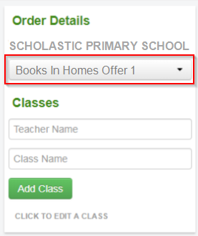

1. Add Teacher name and Class name and click ‘Add Class’

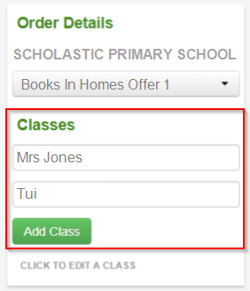

1. Fill out Student names and all choices for each student (Note: All data is automatically saved)

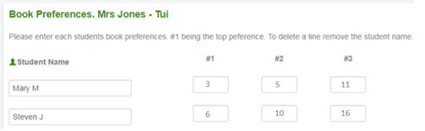

To add another classroom go back to stage 3.

1. When all classes are complete click on **‘CONFIRM ORDER’**

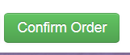

You will see a summary of your order.

1. Click on **‘SUBMIT ORDER’** if you are happy with the order, if not click on ‘EDIT’ to change it.

Your order will show as pending, which means your order has been sent to Scholastic for processing.

**\*\* You can now view this – and any other orders – in ‘MY ORDERS’ / ‘SUBMITTED ORDERS’ \***