**GOVERNMENT BOOK OFFER, 2025 - INSTRUCTIONS**

***The Alan Duff Charitable Foundation***

Dear Principal and Duffy Coordinator

Presenting Book Offer TWO, 2025.

This includes five specially chosen books one from each level and a Te Reo title:

* **Age 5-6:** *Pipi Dance*
* **Age 7-9:** *Dragon Girls: Phoebe the Moonlight Dragon*
* **Age 10-12:** *My New Zealand Story: The Wahine Disaster*
* **Advanced:** *Kidnapped from Ukraine: Under Attack*
* **Te Reo Maori:** *Te Mahi a te Kihi! (Oh, So Many Kisses!)*

**ONLINE ORDERING ONLY**

**Please follow these instructions carefully to ensure prompt and efficient delivery of your books.**

This package contains the following items:

* **Complimentary highlights preview pack**
* **Brochures**
* **Class Order Form**

### NOTE these two important dates:

* Orders submitted by **Friday 9th May** willreceive two **FREE** books for your library.
* **The CLOSING DATE** for this offer is **Friday 16th May 2025**

**Submit your orders to Scholastic using the online portal at**

[**http://bih.scholastic.co.nz/**](http://bih.scholastic.co.nz/)

Please distribute your books at a special assembly during the week of **23rd-27th June**. This is **Government Book Week**. Please arrange for your local MP, mayor, councilor or another prominent member of your community to attend your assembly.

Government Book labels will be sent with the books. The labels will say **‘Given by The Government and Duffy Books in Homes’.** Please ensure each book has a label affixed before handing the books out to your students.

**THANK YOU SCHOLASTIC – PROUDLY SPONSORING THE COMPLIMENTARY HIGHLIGHTS PACKAGE**

GOVERNMENT BOOK OFFER, 2025 - INSTRUCTIONS

***The Alan Duff Charitable Foundation***

* Photocopy the **Class Order Form** below and give one to each teacher.
* Distribute a **Brochure** to each child.
* Books are grouped based on age but **children may choose** **any** book from the brochure.
* Blue section: 5-6 year olds
* Yellow section: 7-8 year olds
* Purple section: 9-10 year olds
* Green section: 11 years +
* Scholastic New Zealand sponsors the complimentary highlights books for your school to keep.
* Students must select **FOUR** books each, in order of preference, and fill out the **Student Order Form** on the back of the brochure. (Your students will receive **two** of their four choices).
* **ONLY current student’s** may order books – if you have students starting after orders submitted, then you may use your Caught Being Good books to present to them at the assembly.
* Teachers then collate student orders onto the **Class Order Form**. Please enter the code numbers of the four chosen books next to the names of the students.
* Before entering your orders online check:
  + Is the School/Teacher's Name and Room Number on every Class Order Form?
  + Has every child made **FOUR** selections?
* Enter your Class Order Forms online at [**http://bih.scholastic.co.nz/**](http://bih.scholastic.co.nz/)

(Some of our larger schools could have a senior student and/or parent to volunteer to help with online entering as this can be done out of school hours)

**Please submit your orders by the closing date:**

**Friday 16th May, 2025 (or Friday 9th May to receive two free books for your school)**

CLASS ORDER FORM

***The Alan Duff Charitable Foundation***

##### BOOK OFFER 2, 2025

|  |  |  |  |  |  |
| --- | --- | --- | --- | --- | --- |
|  | **1ST** | **2ND** | **3RD** | **4TH** | **NAME** |
| **1** |  |  |  |  |  |
| **2** |  |  |  |  |  |
| **3** |  |  |  |  |  |
| **4** |  |  |  |  |  |
| **5** |  |  |  |  |  |
| **6** |  |  |  |  |  |
| **7** |  |  |  |  |  |
| **8** |  |  |  |  |  |
| **9** |  |  |  |  |  |
| **10** |  |  |  |  |  |
| **11** |  |  |  |  |  |
| **12** |  |  |  |  |  |
| **13** |  |  |  |  |  |
| **14** |  |  |  |  |  |
| **15** |  |  |  |  |  |
| **16** |  |  |  |  |  |
| **17** |  |  |  |  |  |
| **18** |  |  |  |  |  |
| **19** |  |  |  |  |  |
| **20** |  |  |  |  |  |
| **21** |  |  |  |  |  |
| **22** |  |  |  |  |  |
| **23** |  |  |  |  |  |
| **24** |  |  |  |  |  |
| **25** |  |  |  |  |  |
| **26** |  |  |  |  |  |
| **27** |  |  |  |  |  |
| **28** |  |  |  |  |  |
| **29** |  |  |  |  |  |
| **30** |  |  |  |  |  |
| **31** |  |  |  |  |  |
| **32** |  |  |  |  |  |
| **33** |  |  |  |  |  |
| **34** |  |  |  |  |  |
| **35** |  |  |  |  |  |
| **36** |  |  |  |  |  |

INSTRUCTIONS FOR ORDERING ONLINE

1. Log into bih.scholastic.co.nz
2. If you are a new user please register (you will receive an e mail verification that you will need to click on)
3. Select the Offer, e.g. Book Offer 2

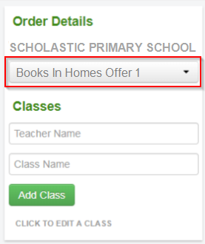

1. Add Teacher name and Class name and click ‘Add Class’

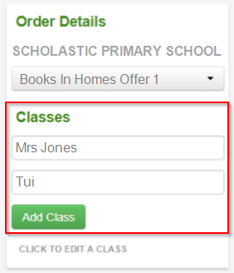

1. Fill out Student names and all choices for each student (Note: All data is automatically saved)

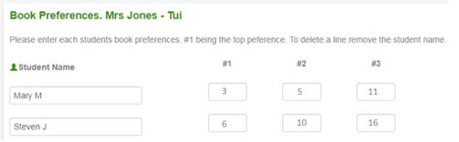

To add another classroom go back to stage 3.

1. When all classes are complete click on **‘CONFIRM ORDER’**

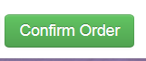

You will see a summary of your order.

1. Click on **‘SUBMIT ORDER’** if you are happy with the order, if not click on ‘EDIT’ to change it.

Your order will show as pending, which means your order has been sent to Scholastic for processing.

**\*\* You can now view this – and any other orders – in ‘MY ORDERS’ / ‘SUBMITTED ORDERS’ \***