BOOK OFFER ONE, 2024 - INSTRUCTIONS
The Alan Duff Charitable Foundation
Dear Principal and Duffy Coordinator

We are pleased to present Book Offer ONE, 2024.

This includes five specially chosen books one from each level and a Te Reo title:

Age 5-6: Dusty the Digger
Age 7-9: Dragon Games #1 The Thunder Egg
Age 10-12: Kid YouTuber Season 1
Advanced: Marvel Black Panther: Uprising
Te Reo Maori: Sun Shower / He Taru Kahika

ONLINE ORDERING ONLY

Please follow these instructions carefully to ensure prompt and efficient delivery of your books.

This package contains the following items:

- Complimentary highlights preview pack
- Brochures
- Class Order Form

NOTE these two important dates:

- Orders submitted by Friday 9 February will receive two FREE books for your library.

- The CLOSING DATE for this offer is Friday 16th February 2024.

Submit your orders to Scholastic using the online portal at:

http://bih.scholastic.co.nz/

Duffy Books in Homes organise Role Models to visit your school for Role Model assemblies
twice a year, over the last five weeks of Terms One and Three. Book Offer One and Book Offer
Three books are presented at these assemblies. We ask you to arrange a special assembly for
the Role Model to celebrate/present your Book Offer book
Refer to your Duffy Year Planner 2024 for dates. If you have any questions or problems with the Book Offer, preview pack books or ordering, please call: Scholastic New Zealand - Customer Services: 0800 724 652
THANK YOU SCHOLASTIC – PROUDLY SPONSORING THE COMPLIMENTARY HIGHLIGHTS PACKAGE

BOOK OFFER ONE, 2024 - INSTRUCTIONS
The Alan Duff Charitable Foundation

- Photocopy the Class Order Form below and give one to each teacher.

- Distribute a Brochure to each child.

- Books are graded according to age groups but children may choose any book from the brochure.

- Yellow section: 5-6 year olds
- Blue section: 7-8 year olds
- Purple section: 9-10 year olds
- Green section: 11 years +

- Scholastic New Zealand sponsors the complimentary highlights books. The books are donated to your school to keep.

- Students must select FOUR books each, in order of preference, and fill out the Student Order Form on the back of the brochure. (Your students will receive two of their four choices).

- ONLY current students may order books – if you have students starting after orders have been sent in then you may use your Caught Being Good books to present to them at the assembly.

- Teachers then collate student orders onto the Class Order Form. Please enter the code numbers of the four chosen books next to the names of the students.

- Before entering your orders online check:

  - Is the School/Teacher's Name and Room Number on every Class Order Form?
  - Has every child made FOUR selections?

- Enter your Class Order Forms online at http://bih.scholastic.co.nz/
(Some of our larger schools could have a senior student and/or parent to volunteer to help with online entering as this can be done out of school hours)

Please submit your orders by the closing date:

Friday 16th February (or Friday 9th February to receive two free books for your school)

CLASS ORDER FORM
The Alan Duff Charitable Foundation

BOOK OFFER 1, 2024

 | 1ST | 2ND | 3RD | 4TH | NAME
1
2
3
4
5
6
7
8
9
10
11
12
13
14
15
16
17
18
19
20
21
22
23
24
25
26
27
28
29
30
31
32
33
34
35

Class: ________________________ Teacher: ____________________________

INSTRUCTIONS FOR ORDERING ONLINE

- Log into bih.scholastic.co.nz
- If you are a new user please register (you will receive an e mail verification that you will need to click on)
- Select the Offer, e.g. Book Offer 1
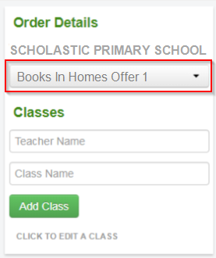

- Add Teacher name and Class name and click ‘Add Class’
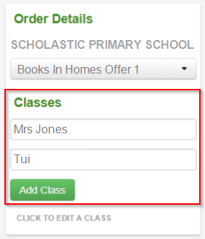

- Fill out Student names and all choices for each student (Note: All data is automatically saved)
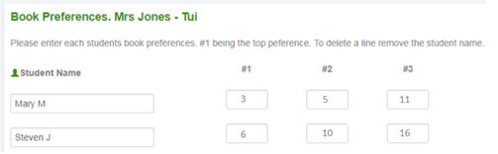

To add another classroom go back to stage 3.
- When all classes are complete click on ‘CONFIRM ORDER’
You will see a summary of your order.

- Click on ‘SUBMIT ORDER’ if you are happy with the order, if not click on ‘EDIT’ to change it.
Your order will show as pending, which means your order has been sent to Scholastic for processing.
** You can now view this – and any other orders – in ‘MY ORDERS’ / ‘SUBMITTED ORDERS’ *

